Manthan Arvind Naik SE2 CSEDS 39

Experiment 6

Title

Create a webpage that retrieves, displays, and updates user data from a MySQL database. Implement CRUD operations (Create, Read, Update, Delete) using PHP & MySQL. Ensure user input is validated and securely stored in the database. Add Session & Cookies.
Theory:
Modern web applications often require interaction with databases to store, retrieve, and manage user information efficiently. This experiment focuses on developing a dynamic web application using PHP and MySQL that performs CRUD operations (Create, Read, Update, Delete) on user data. Additionally, the application ensures input validation, secure data storage, and incorporates Sessions and Cookies for user management
- PHP and MySQL Integration
PHP (Hypertext Preprocessor) is a server-side scripting language widely used for web development. It is especially suitable for database-driven applications because it can easily interact with databases like MySQL.
MySQL is an open-source relational database management system (RDBMS) used to store structured data in tables. PHP communicates with MySQL using extensions such as MySQLi or PDO (PHP Data Objects) to execute SQL queries.
In this experiment, PHP scripts handle database connections, execute SQL commands, and dynamically generate HTML output based on database records.

CRUD Operations
CRUD represents the four fundamental database operations:

1. Create (Insert)
The Create operation is used to add new user records into the database. User data is collected through HTML forms and sent to the server using HTTP POST method. PHP processes the input and inserts validated data into the MySQL table using the INSERT SQL statement.

2. Read (Select)
The Read operation retrieves user data from the database and displays it on the webpage. PHP executes the SELECT SQL query and fetches records, which are displayed dynamically in tabular format. This operation allows users to view stored data.

3. Update
The Update operation modifies existing user records. The selected record is loaded into an HTML form, allowing the user to edit data. PHP then updates the record in the database using the UPDATE SQL statement.

4. Delete
The Delete operation removes unwanted records from the database using the DELETE SQL statement. This operation helps maintain accurate and relevant data.

Database Structure
A MySQL database typically contains:
- A database to store application data
- A table to store user information such as ID, name, email, and password
- A primary key to uniquely identify each record
Relational databases ensure data consistency and integrity through structured schema and constraints.

Input Validation
Input validation is essential to ensure that user-provided data is correct and safe. Validation includes:
- Checking for empty fields
- Validating email format
- Restricting input length
- Allowing only valid characters
Validation can be implemented using both client-side validation (HTML/JavaScript) and server-side validation (PHP). Server-side validation is critical, as client-side validation can be bypassed.

Security Measures

SQL Injection Prevention
SQL Injection is a common attack where malicious SQL code is inserted into input fields. To prevent this:
- Prepared statements
- Parameterized queries
are used to securely execute SQL commands.

Password Security
Passwords should never be stored in plain text. PHP provides hashing functions such as password_hash() to securely store passwords and password_verify() to authenticate users.

Sessions
A session is a server-side mechanism used to store user data temporarily across multiple pages. Sessions are commonly used for:
- User login systems
- Authentication
- Maintaining user state
In PHP, sessions are created using session_start() and data is stored in session variables. Session data is automatically destroyed when the browser is closed or the session expires.

Cookies
A cookie is a small piece of data stored on the client’s browser. Cookies are used to:
- Remember user preferences
- Store login information
- Track user activity
Unlike sessions, cookies have an expiration time and remain stored even after the browser is closed. PHP uses the setcookie() function to create cookies.

Dynamic Web Page Behavior
The application dynamically updates content based on database operations. PHP fetches updated records after every CRUD operation, ensuring that the displayed data always reflects the current state of the database.
Algorithm/Procedure:

A. Database Creation
- Start XAMPP/WAMP server.
- Open phpMyAdmin.
- Create a database named userdb.
B. CRUD Operations Flow
- Create a table users with fields:
  - id (INT, Primary Key, Auto Increment)
  - name (VARCHAR)
  - email (VARCHAR)
  - password (VARCHAR)
Steps:
- User enters details in HTML form.
- PHP validates user input.
- Data is securely inserted into MySQL database.
- Existing records are fetched and displayed.
- User can update or delete records.
- Sessions manage login state.
- Cookies store user preference.
Program/Code:
1. Database Connection (db.php)
<?php
$conn = mysqli_connect("localhost", "root", "", "userdb");

if (!$conn) {
die("Database connection failed");
}
?>

2️.Create (Insert) User
<?php
include "db.php";

if (isset($_POST['submit'])) {
$name = trim($_POST['name']);
$email = trim($_POST['email']);
$pass = password_hash($_POST['password'], PASSWORD_DEFAULT);

if (!empty($name) && !empty($email)) {
$query = "INSERT INTO users(name,email,password) VALUES('$name','$email','$pass')";
mysqli_query($conn, $query);
header("Location: index.php");
}
}
?>
3.Read (Display Data) – index.php
<?php include "db.php"; ?>
<html>
<body>
<h2>User List</h2>

<table border="1">
<tr>
<th>ID</th><th>Name</th><th>Email</th><th>Action</th>
</tr>

<?php
$result = mysqli_query($conn, "SELECT * FROM users");
while ($row = mysqli_fetch_assoc($result)) {
?>
<tr>
<td><?= $row['id']; ?></td>
<td><?= $row['name']; ?></td>
<td><?= $row['email']; ?></td>
<td>
<a href="edit.php?id=<?= $row['id']; ?>">Edit</a> |
<a href="delete.php?id=<?= $row['id']; ?>">Delete</a>
</td>
</tr>
<?php } ?>
</table>
</body>
</html>

4️.Update Operation (edit.php)
<?php
include "db.php";
$id = $_GET['id'];

if (isset($_POST['update'])) {
$name = $_POST['name'];
$email = $_POST['email'];

mysqli_query($conn, "UPDATE users SET name='$name', email='$email' WHERE id=$id");
header("Location: index.php");
}

$data = mysqli_fetch_assoc(mysqli_query($conn, "SELECT * FROM users WHERE id=$id"));
?>
<form method="post">
<input type="text" name="name" value="<?= $data['name']; ?>">
<input type="email" name="email" value="<?= $data['email']; ?>">
<button name="update">Update</button>
</form>
5. Delete Operation (delete.php)
<?php
include "db.php";
$id = $_GET['id'];

mysqli_query($conn, "DELETE FROM users WHERE id=$id");
header("Location: index.php");
?>
6. Session Management (session.php)
<?php
session_start();
$_SESSION['user'] = "Admin";
?>

Cookie Example
<?php
setcookie("username", "Student", time() + 3600);
?>

Output:
(Give output with respect to following:
User details are inserted into the database.
- Records are displayed dynamically in tabular format.
- Users can edit and delete records.
- Sessions maintain user login state.
- Cookies store user-related information.
- All operations are performed successfully without page reload errors.)

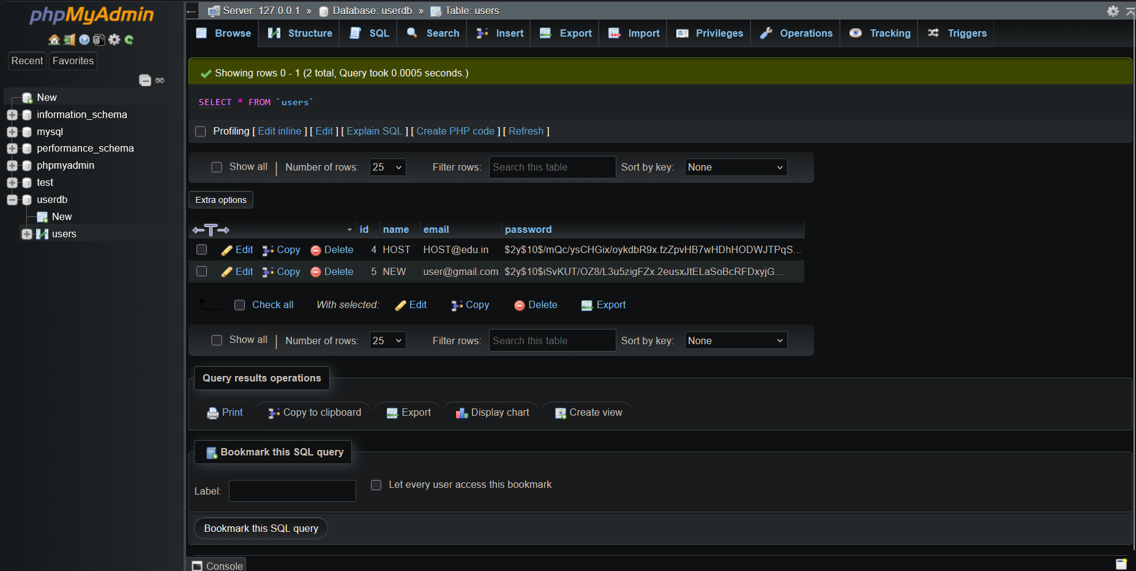
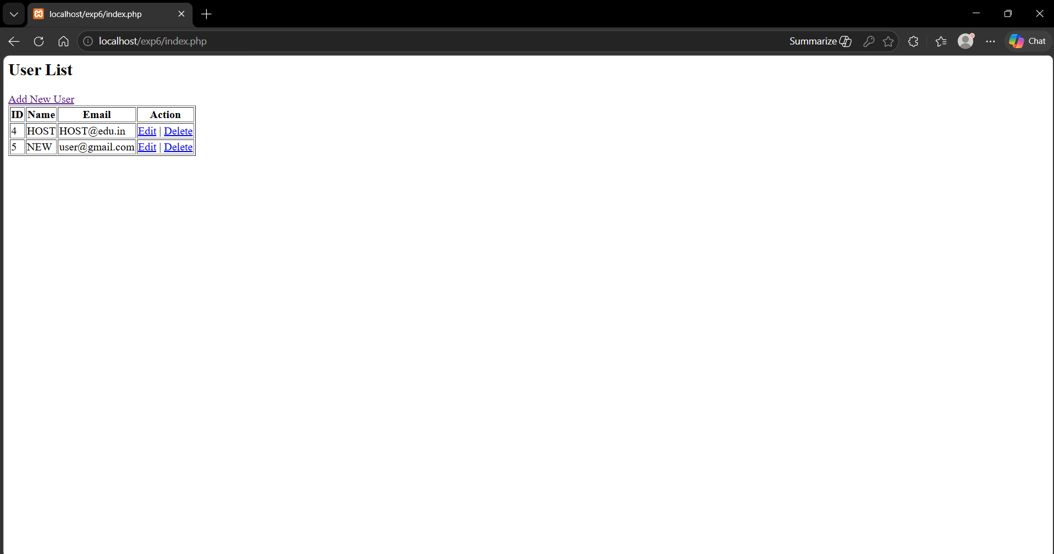
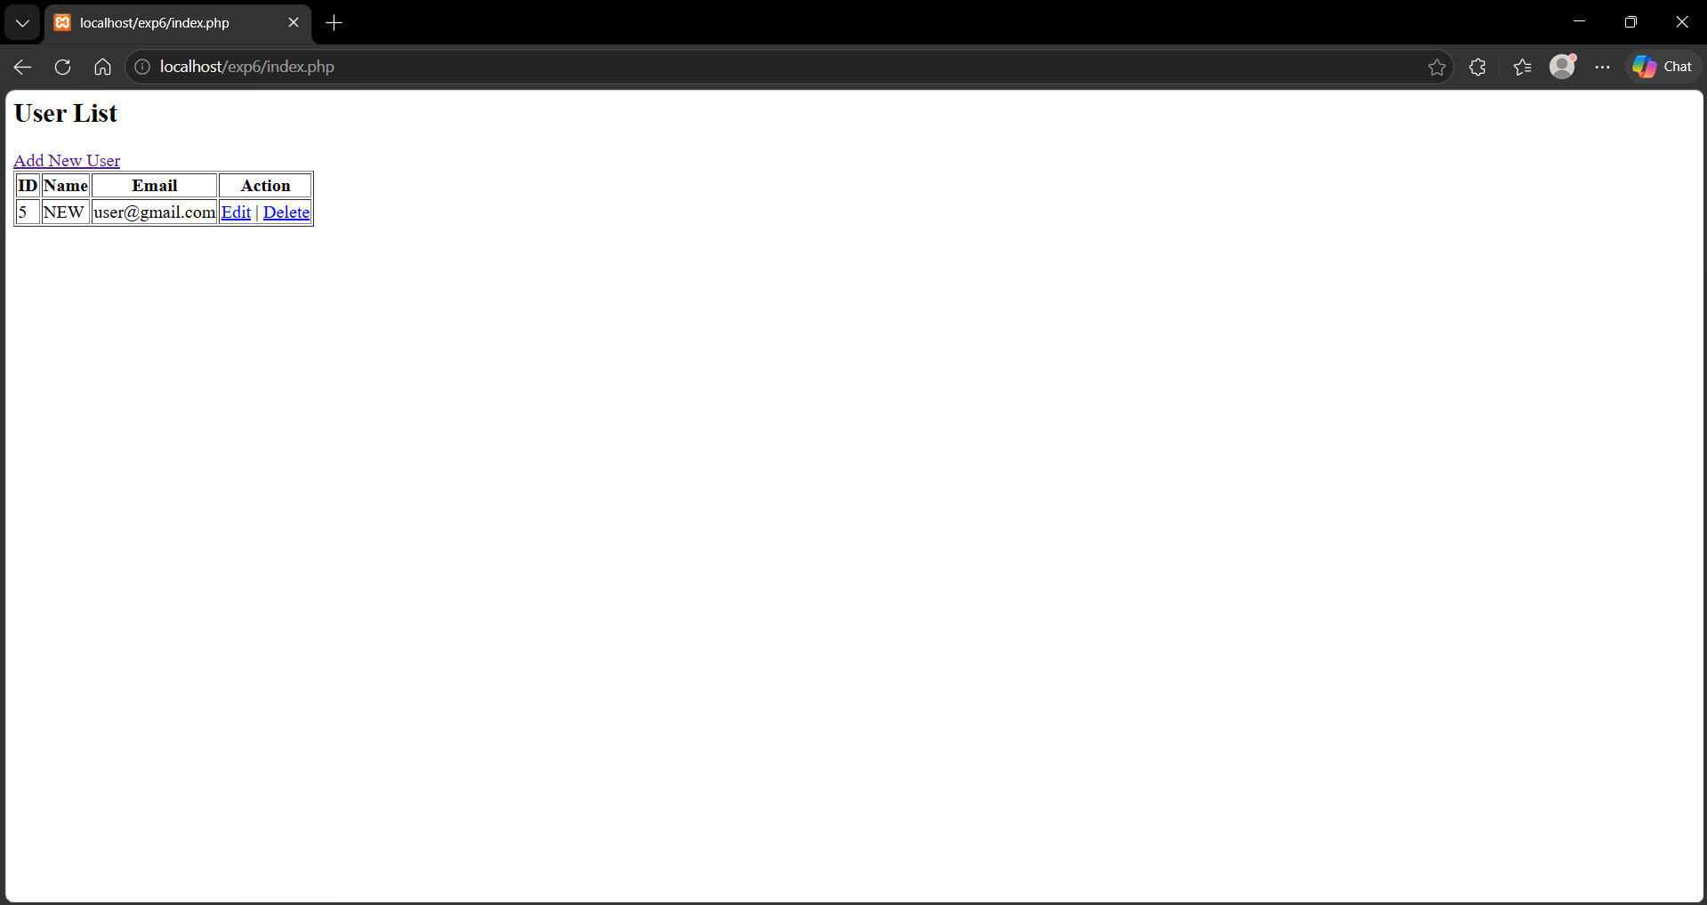
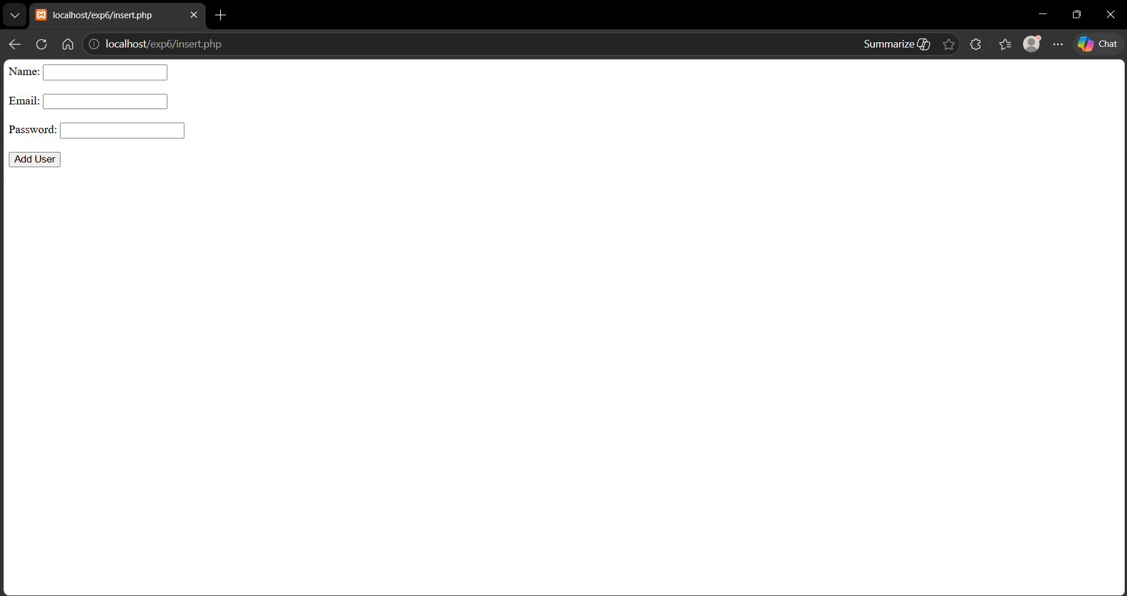
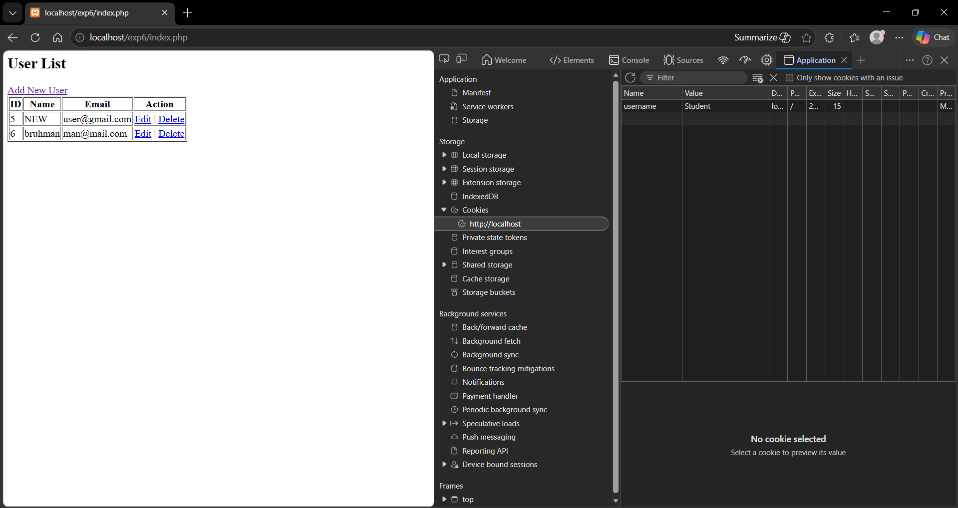

Conclusion
Thus, a dynamic database-driven web application was successfully developed using PHP and MySQL. CRUD operations were implemented with secure data handling, input validation, and session & cookie management. This experiment demonstrates real-world server-side web development concepts.
Question:
- What is the role of PHP in database connectivity?
PHP acts as a server-side scripting language that enables communication between a web application and a database such as MySQL. It is used to:
- Establish a connection with the database using functions like mysqli_connect()
- Execute SQL queries such as INSERT, SELECT, UPDATE, DELETE
- Fetch and process data from the database
- Dynamically display database content on web pages
Thus, PHP serves as a bridge between the frontend (HTML) and the backend database (MySQL).
- Difference between session and cookie?
Sessions and cookies are both used to store user-related information in web applications, but they differ in how and where the data is stored. A session stores data on the server side, making it more secure and suitable for sensitive information like user authentication and login status. Session data is temporary and usually destroyed when the browser is closed or the session expires. In contrast, a cookie is stored on the client’s browser, making it less secure but useful for storing small pieces of data such as user preferences or remembering login details. Cookies have an expiration time and can persist even after the browser is closed. Thus, sessions are preferred for secure data handling, while cookies are used for lightweight, client-side storage.
- How are passwords secured in PHP?
Passwords in PHP are secured using hashing techniques instead of storing them as plain text.
- PHP provides:
  - password_hash() → Converts password into a secure hashed format
  - password_verify() → Verifies entered password with stored hash

